Ideation Phase Define the Problem Statements

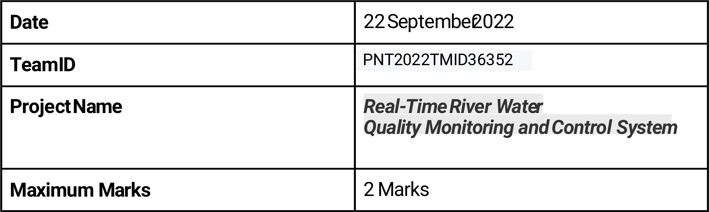

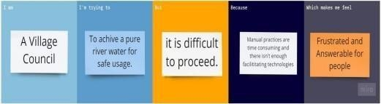

|  |  |  |  |  |  |
| --- | --- | --- | --- | --- | --- |
| Problem  Statement  (PS) | I am  (Customer) | I’m trying to | But | Because | Which makes me feel |
| PS-1 | I’m an | I’m trying | But I can’t | Because | It makes |
|  | villager | to take an | achieve | of | me |
|  | who | initiative of | due to that | poisonous | frustrated |
|  | suffers | consuming | I can’t find | state of | and |

|  |  |  |  |  |  |
| --- | --- | --- | --- | --- | --- |
|  | from | pure | proper | water we | makes me |
|  | impure | river water | method | are unable | answerable |
|  | water | that | than | to use it | for the |
|  | issues. | prevent | manual | efficiently | health and |
|  |  | major and | practices | because it | Risk factors |
|  |  | minor | or can’t | creates | that the |
|  |  | health | find an apt | major and | villagers |
|  |  | issues in | product. | minor | take. |
|  |  | people. |  | health issues to villagers. |  |
| PS-2 | I’m an | I’m | But often | Since use | It makes |
|  | farmer. | developing | get | Of fertilizers | me to feel |
|  |  | food and | disappointed | Itself | the |
|  |  | Forage | due to | produce | clueless |
|  |  | crops. | chemical | necessary | about my |
|  |  |  | imbalance | growth in | Farming |
|  |  |  | in the water | crops the | technique |
|  |  |  | Supply from | untreated | s and |

|  |  |  |  |  |  |
| --- | --- | --- | --- | --- | --- |
|  |  |  | river. | river water Creates  decay of  crops which goes to waste. | survival. |